**Circuit Diagram:**

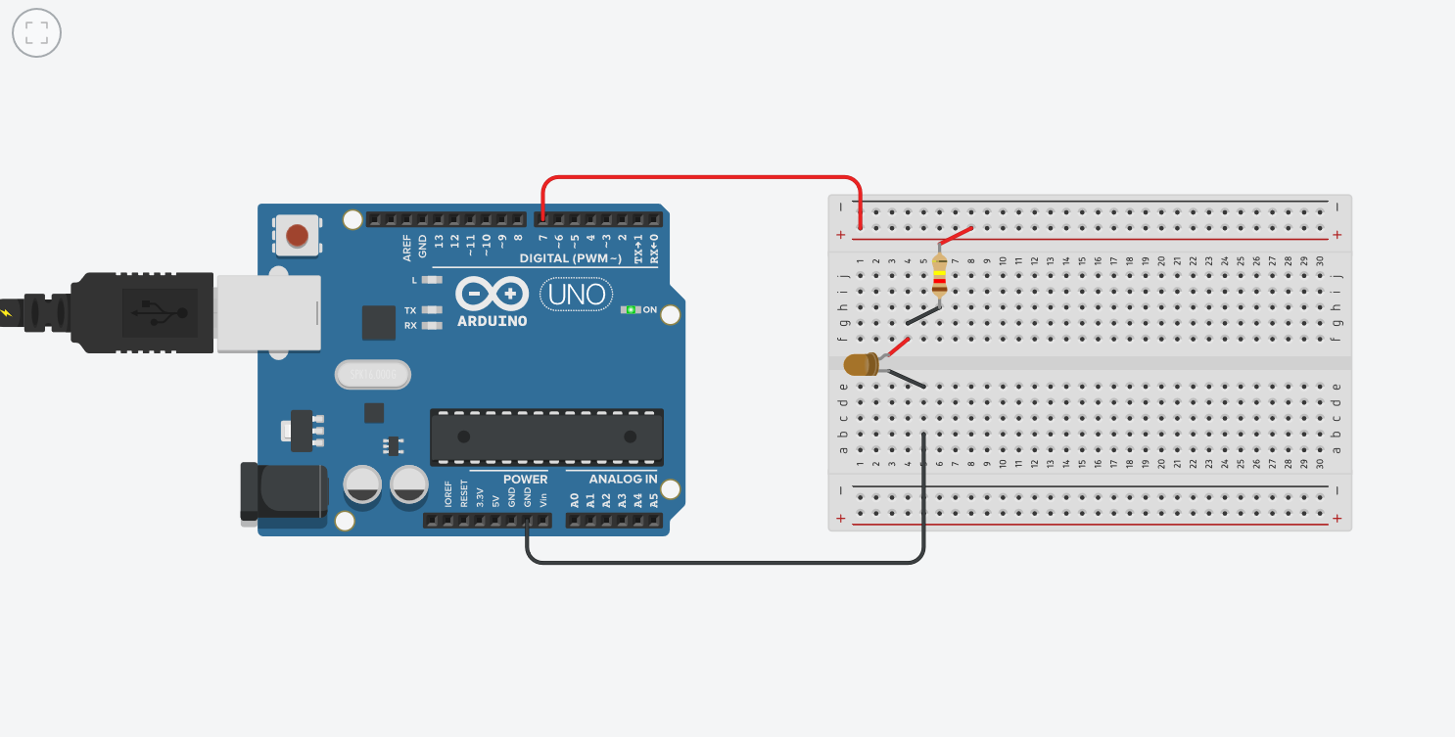

**Theory:**

1. **Concept Used:**

* On changing the amount of voltage supplied, the LED turns on & off.
* When voltage is high LED turns on and vice cersa.

1. **Learning & Observations:**

* LED start blinking(or flashing) with a interval of 1 second

1. **Problems & Troubleshooting:**

* Connections can be wrong.
* Code for the design can be wrong or not uploaded to the Arduino properly.

1. **Precautions:**

* All connections must be neat and tight.
* All connections must be correct.

1. **Learning Outcomes:**

* Code a program for Arduino.
* Make connections using Breadboard.